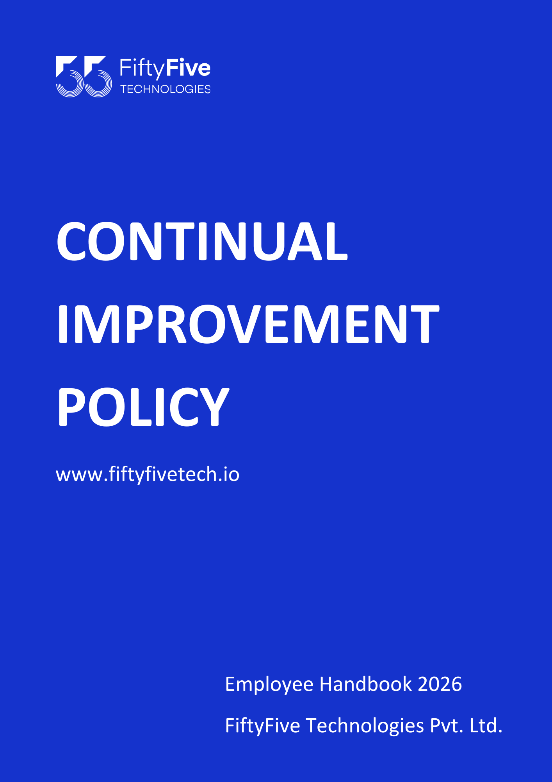

Continual Improvement Policy

Document Release Notice

This FiftyFive Technologies Policy on continual improvement policy is released for use in FiftyFive Technologies Pvt Limited with effect from 01 January 2026.

This document is subject to FiftyFive Technologies Pvt Limited Procedure and subject to change at any time as per the company policy.

Approved By: Jyothi Sharma (CEO-FiftyFive Technologies Pvt. Limited)
Approved By: Sanchi Saxena (Head HR-FiftyFive Technologies Pvt Limited)

1. Purpose
The purpose of this Continual Improvement Policy is to define the framework and principles for continuously enhancing the quality and effectiveness of FiftyFive Technologies's products, services, and processes. This policy aims to foster a culture of improvement and innovation throughout the organization.

2. Scope
This policy applies to all employees, departments, and functions within FiftyFive Technologies. It encompasses all aspects of operations, including product development, service delivery, and process management.

3. Definitions
- Continual Improvement: An ongoing effort to enhance products, services, and processes to achieve better performance, efficiency, and effectiveness.
- Improvement Opportunity: A chance to enhance or optimize processes, products, or services based on feedback, performance data, or changing requirements.

4. Policy Statement
FiftyFive Technologies is committed to the continual improvement of its operations, products, and services. We strive to exceed customer expectations, improve performance, and adapt to changes in the industry and market conditions. All employees are encouraged to contribute to the improvement process by identifying opportunities and implementing solutions.

5. Principles of Continual Improvement
- Customer Focus: Understand and meet customer needs and expectations. Use customer feedback to drive improvements.
- Data-Driven Decision Making: Use data and performance metrics to identify areas for improvement and measure the effectiveness of improvement actions.
- Employee Involvement: Engage employees at all levels in the improvement process. Encourage and recognize their contributions and ideas.
- Process Approach: Focus on improving processes to achieve better results. Identify and eliminate inefficiencies and bottlenecks.
- Leadership Commitment: Demonstrate leadership and support for continual improvement initiatives. Allocate resources and provide guidance to ensure success.
- Innovation: Foster a culture of innovation by encouraging creative thinking and exploring new approaches to problem-solving.

6. Continual Improvement Process

6.1 Identification of Improvement Opportunities
- Feedback: Gather feedback from customers, employees, and other stakeholders to identify areas for improvement.
- Data Analysis: Analyze performance data, audit results, and other metrics to pinpoint inefficiencies or opportunities for enhancement.
- Benchmarking: Compare performance against industry standards and best practices to identify gaps and improvement areas.

6.2 Planning and Implementation
- Action Plan: Develop a plan to address identified improvement opportunities. Include specific actions, responsible individuals, and timelines.
- Resource Allocation: Allocate necessary resources, including time, budget, and personnel, to implement improvement initiatives.
- Execution: Implement the action plan, ensuring that all tasks are completed as planned and in accordance with established procedures.

6.3 Monitoring and Evaluation
- Tracking: Monitor the progress of improvement initiatives and track key performance indicators (KPIs) to assess effectiveness.
- Evaluation: Evaluate the results of improvement actions to determine their impact on performance, efficiency, and customer satisfaction.
- Adjustment: Make adjustments as needed based on evaluation results to ensure ongoing effectiveness and continuous improvement.

6.4 Communication and Training
- Communication: Communicate improvement goals, plans, and results to all employees and relevant stakeholders.
- Training: Provide training and support to employees to ensure they understand and can effectively contribute to improvement efforts.

6.5 Review and Feedback
- Review: Conduct regular reviews of the continual improvement process to assess its effectiveness and identify areas for further enhancement.
- Feedback: Collect feedback from employees and stakeholders on the improvement process and use it to refine and improve the policy.

7. Roles and Responsibilities
7.1 Leadership Team
- Support: Provide leadership and support for continual improvement initiatives. Ensure alignment with organizational goals and objectives.
- Resource Allocation: Allocate resources and provide guidance to facilitate the implementation of improvement actions.
7.2 Department Managers
- Implementation: Ensure that improvement initiatives are implemented within their departments and that employees are engaged in the process.
- Monitoring: Monitor departmental performance and identify opportunities for improvement.

7.3 Employees
- Participation: Actively participate in improvement activities, provide feedback, and suggest ideas for enhancing processes and performance.
- Compliance: Follow established procedures and contribute to the successful implementation of improvement initiatives.

8. Policy Compliance and Enforcement
8.1 Compliance
- Regulatory Requirements: Ensure that improvement activities comply with applicable laws, regulations, and industry standards.
- Internal Audits: Conduct regular audits to assess compliance with this policy and identify areas for improvement.
8.2 Enforcement
- Disciplinary Actions: Non-compliance with this policy may result in disciplinary actions. Ensure that enforcement measures are consistent with company policies and legal requirements.

9. Policy Review and Updates
This policy will be reviewed annually or as needed to ensure it remains relevant and effective. Updates will be communicated to all employees and relevant stakeholders.



